title: “Flipped Assignment 04” author: “Md Ariful Haque Miah” date: “3/1/2022” output: pdf_document

# index as x  
x<-c(16.7,17.1,18.2,18.1,17.2,18.2,16.0,17.2,18.0,17.2,16.9,17.1,18.2,17.3,17.5,16.6)  
# days as y  
y<-c(91,105,106,108,88,91,58,82,81,65,61,48,61,43,33,36)  
length(x)

## [1] 16

# Answer to the ques no. a  
plot(x,y,main="ScatterPlot of x and y")  
  
# Answer to the ques no. b  
model<-lm(y~x)  
model

##   
## Call:  
## lm(formula = y ~ x)  
##   
## Coefficients:  
## (Intercept) x   
## -193.0 15.3

summary(model)

##   
## Call:  
## lm(formula = y ~ x)  
##   
## Residuals:  
## Min 1Q Median 3Q Max   
## -41.70 -21.54 2.12 18.56 36.42   
##   
## Coefficients:  
## Estimate Std. Error t value Pr(>|t|)  
## (Intercept) -192.984 163.503 -1.180 0.258  
## x 15.296 9.421 1.624 0.127  
##   
## Residual standard error: 23.79 on 14 degrees of freedom  
## Multiple R-squared: 0.1585, Adjusted R-squared: 0.09835   
## F-statistic: 2.636 on 1 and 14 DF, p-value: 0.1267

# Slope beta1 = 15.3 and the intercept beta0 = -193  
# Model equation y_hat= -193 + 15.3 * x  
  
# Answer to the ques no. c  
abline(model)

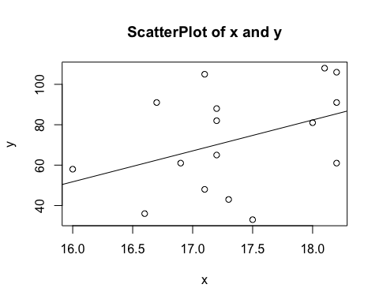

# Answer to the ques no. d  
  
plot(model)

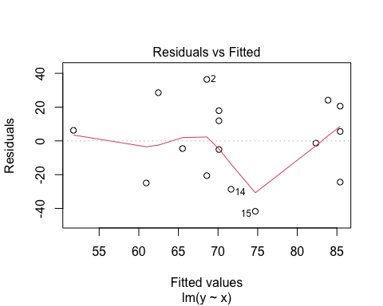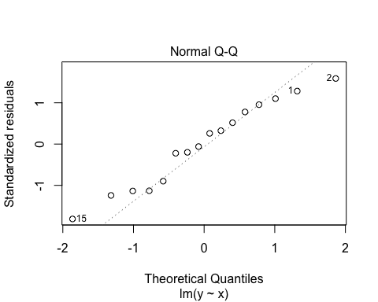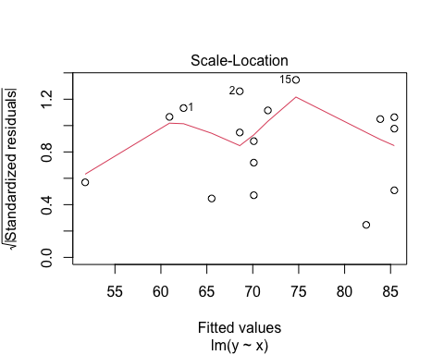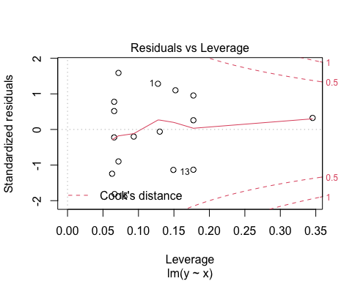

#Constant variance check: Residual vs. fitted value plot shows random scatter  
# which indicates that variance is constant.  
# Normality Check: From the Normal Q-Q plot we can see that the error is normally  
# distributed  
# from the fitted values vs. sqrt(standardized residuals) plot we see that all  
# the data points distance between them is not too higher and within the value   
# 1.5 so it seems that there will be no outliers or possibly observations 1,2   
# and 15 may be outliers  
  
# Answer to the ques no. e  
  
# From the summary of the model, we see that abs value of t is 1.624 which is less  
# than the value of t[alpha/2,n-2] which is 2.144 which does not reject the null   
# hypothesis beta1 = 0 hence the regression is not significant